Cold Ashby Parish Council
A meeting will be held on Tuesday July 2nd 2024 at 7.30 pm at Cold Ashby Pavilion.
Councillors are summoned to attend this meeting of the Parish Council. Members of the public and press are invited to attend.

Agenda

Present: to record the presence of Cold Ashby Parish Councillors, Officers, members of external authorities and others in official attendance at the meeting.

Interests: Members’ attention is drawn to the need to disclose pecuniary interests not already registered before any relevant agenda item.

24.7.1 - Apologies: to receive and consider apologies for absence.

24.7.2 - Minutes: to approve minutes of the Ordinary Meeting of the Council held on June 5th, 2024 (attached).

24.7.3 - Matters arising: to note for information only any relevant matter arising from the approved minutes.

24.7.4 - Open forum: to receive and discuss matters raised by members of the public present at the meeting.

24.7.5 – Accounts: Members are asked to approve the attached accounts for June and authorise the payments contained in them. Details of payments and the new balance are included as Annex A.

24.7.6 – Adoption of Policy for recording of meetings. To approve the draft policy for recording of meetings as amended (attached, Annex B).

24.7.7 – Cemetery.
- To consider and approve the application to erect a memorial to M.M. Lill at Cold Ashby burial ground (attached Annex C)
- To consider and approve the application to erect a vase is an 8" x 8" cube with flower rose at the top at Cold Ashby burial ground (plot 78) in memory of John & Rose Barr (attached Annex C).
24.7.8 – Planning Matters.
- To consider motion as follows, proposed by Councillor Bailey, seconded by Councillor Richard Williams:
“That Cold Ashby Parish Council considers the planning application received from West Northamptonshire Council No. 2024/2784/FULL for
change of use of the Black Horse public house, Main Street Cold Ashby NN6 6EL to a community shop and post office.
That Cold Ashby Parish Council agrees on any comments to be submitted on its behalf to West Northamptonshire Council in response to the consultation notice dated June 10th 2024.”
(See letter attached, Annex D).
- To consider Parish Council response to Planning Application 2024/1210/FULL Installation on solar panels on garage roof, Home Farm Church Lane Cold Ashby NN6 6EG (See letter attached, Annex E).

24.7.9 - Post: to note and/or discuss items of correspondence with the Council not considered elsewhere on the agenda.
To note thanks received from Friends of St Denys Church for Parish Council Grant.

Date of next meeting: Wednesday August 7th, 2024, at 7.30p.m. in the Playing Field Pavilion

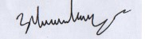

Jonathan Ward-Langman June 20th 2024

Annex A: Cold Ashby Parish Council accounts June 2024
Date | Account | Category | Desc | Credit/Debit | £ | VAT | Total | Notes
01/06/2024 | Main | Opening Balance |  |  |  |  | £16,962.31
01/06/2024 | Savings | Opening Balance |  |  |  |  | £9,758.31
07/06/2024 | Main | Cemetery | J. Stamp Cemetery fees | Credit | £55.00 | £0.00 | £55.00
07/06/2024 | Main | Information Commissioner | ICO | Debit | -£35.00 | £0.00 | -£35.00
14/06/2024 | Main | Consumables/IT | Ionos Cloud | Debit | -£3.00 | -£0.60 | -£3.60 | Incl in May accounts
20/06/2024 | Main | Clerks expenses | N.Heath refund Ionos payment 29/03/24 | Debit | -£3.60 | £0.00 | -£3.60
20/06/2024 | Main | Grasscutting | Thompson Groundcare | Debit | -£407.96 | -£81.59 | -£489.55
20/06/2024 | Main | Grasscutting | Thompson Groundcare | Debit | -£407.96 | -£81.59 | -£489.55
20/06/2024 | Main | Special projects | St. Denys Church grant | Debit | -£640.00 | £0.00 | -£640.00
 | Main | Total |  |  |  |  | -£1,606.30
 | Savings | Total |  |  |  |  | £0.00
Above payments authorised:
June 5th 2024 | Clerk | Jonathan Ward-Langman
 | Councillor |  |  | Main Account |  |  | £15,356.01
 | Councillor |  |  | Savings account |  |  | £9,758.31
 |  |  |  | Month Balance |  |  | £25,114.32
 | Date:
BANK RECONCILIATION FOR COLD ASHBY PARISH COUNCIL MEETING JUNE 2nd 2024
Name of smaller authority: | Cold Ashby Parish Council
County area (local councils and parish meetings only): |  |  | West Northamptonshire
Financial year ending 31 March 2025
Prepared by (Name and Role): | Jonathan Ward-Langman Clerk/ RFO
Date: | 20/06/2024
 |  |  |  |  | £ | £
Balance per bank statements as at 05/06/24
Business Current Account 1045 | account 1 |  |  |  | £15,356.01
Business Reserve Account 2605 | account 2 |  |  |  | £9,758.31
 | account 3
 |  |  |  |  |  | £25,114.32
Petty cash float (if applicable) |  |  |  |  |  | £0.00
Less: any unpresented cheques as at 20/6/24 (enter these as negative numbers) |  |  |  |  |  | £0.00
Net balances as at 05/06/24 (Box 8) |  |  |  |  |  | £25,114.32

Invoices for approval Cold Ashby Parish Council EGM July 2nd 2024
Date | Account | Category | Description | Credit/Debit | £ |  | VAT |  | Total
07/06/24 | Main | Prof. services, Cllr. A Chantler | Audit fees | Debit | 25.00 |  | 0.00 |  | 25.00
30/06/24 | Main | Clerk’s salary/PAYE | Salary | Debit | 708.60 |  | 0.00 |  | 708.60
30/06/24 | Main | Clerk’s salary/PAYE | HMRC | Debit | 174.00 |  | 0.00 |  | 174.00
25/06/2024 | Main | Defibrillator | The Community Heartbeat Trust (Battery supply) | Debit | 222.50 |  | 44.50 |  | 267.00
26/06/24 | Main | Grasscutting | Thompson Groundcare | Debit | 407.96 |  | 81.59 |  | 489.55
Above payments authorised:
 | Clerk | Jonathan Ward-Langman
 | Councillor
 | Councillor
 | Date:

Annex B
Cold Ashby Parish Council
Recording at Parish Council Meetings Policy
June 2024
CONTENTS
Detail of chapters | Page Number
Introduction | 1
Parish Council recording obligations and duties | 2
Rules of members of public or press recording the Parish Council meetings | 3

1. INTRODUCTION
- This policy will cover the recording of Parish Meetings by members of the community as well as the Council itself recording the meeting.
- The term “recording” covers the audio, visual or any kind of electronic recording.
- The right to record, film and to broadcast meetings of the parish meeting is established under the Openness of Local Government Regulations 2014. This is in addition to the rights of the press and public to attend such meetings.
- The Council is committed to being open and transparent in the way it conducts its decision making.
- The Council fully appreciates that any recording of meetings will need to be stored securely and will be covered by Freedom of Information (FoI) and General Data Protection Regulations (GDPR) legislation.
- All Council meetings may be recorded in either a visual, audible or electronic manner. Recording of a meeting or a section of a meeting will be clearly noted in the minutes
- The physical minutes of the meeting, which are usually taken by the Clerk and voted by the Full Council at the next Full Council meeting will remain the statutory and legally binding formal record of council decisions.
- In any discrepancy between any recordings and written minutes, the Council are steadfast in using the written minutes as the primary record.

2. COUNCIL RECORDING OBLIGATIONS AND DUTIES
- The Parish Council may itself photograph, film, record or broadcast meetings and can retain, use or dispose of such material in accordance with its retention and disposal policies.
- Where a council records its own meetings, it will be bound by this policy.
- The Council will ensure that in all face-to-face meetings, there are clear signs of the fact that the meeting is being recorded.
- The Chair will propose a motion when recording is not appropriate for either a full meeting or a section of meeting – if agreed this will be clearly noted in the minutes.
- If any Council meeting is held digitally, the Chair will ensure that it is clearly expressed that the meeting is being recorded.
- The Councillors, Clerks and Council officers have given their permission to be recorded as part of their role.
- Any members of the public or press who have attended any meeting (both face to face and digitally) will be warned by the Chair that by remaining at the meeting they have in effect given their express permission to be recorded. If any members of the public or press do not want to be filmed, they may choose to leave the meeting before recording commences or to move to an area outside the range of the Council’s recording equipment.
- The Clerk shall ensure that for any meetings that are recorded, the act of the recording is made clear in the minutes.
- Council shall ensure that any recording is held securely behind a password protected access process. Any request for access by any persons (other than the Clerk) should be made in writing to the Chair who will take the request to the next full meeting for discussion and a decision to grant the request – this will be highlighted in the publication scheme.
- The Council will determine that how long the recordings are kept and it will be detailed in the Retention and Disposal of Documents and Data Policy. The policy will have specific reference to the GDPR and best practice guidance from the Information Commissioners Office (ICO).
3. RULES OF MEMBERS OF THE PUBLIC RECORDING MEETINGS
- The Council recognises that the general public have a right to record the meetings.
- The Chair will remind all members of the public in attendance of the meeting or a participant in the digital meeting that the act of recording is with permission of the Council.
- In regard to agenda points when the public and press are excluded, no recording by the press or public will be permitted.
- The Chair will remind all members of the public and press that any recording of any meetings (either in full or part) will not be permitted to cause any disruption of any part of the Council meeting.
- Any person making the recording may move around, however in doing so they must ensure that there is minimal or no disruption to the proceedings of the meeting.
- The council requests that all recording is overt (i.e. clearly visible to anyone at the meeting).
- A person or persons making a recording has no right to interrupt the formal part of the Parish meeting by asking questions or making comments for the purpose of the recording.
- The person recording has no right to ask councillors, officers or any members of the public who have been given permission to contribute orally to the meeting to repeat a statement for the purposes of the recording.
- The Chairman of the meeting has absolute discretion to stop or suspend recording if, in their reasonable opinion, continuing to do so would prejudice proceedings at the meeting or if the person recording is in breach of these rules.
- Persons who are recording are requested not to leave their equipment unattended where possible and are responsible for their equipment at all times.
- The recording and reporting on meetings of the Parish Council, is subject to the law and it is the responsibility of those doing the recording and reporting to ensure compliance.
- The council expects that the recording will not be edited in a way that could lead to misinterpretation or misrepresentation of the proceedings or infringement of the Parish Council’s values or in a way that ridicules or shows a lack of respect for those in the recording.
- The Parish Council would expect any recording in breach of these rules to be removed from public view. The Parish Council will have no liability for material published by any other person unless it is itself undertaking the publication through its offices.
- The Parish Council is not liable for the actions of any person making a recording at a council meeting which identifies a member of the public or for any publication of that recording.
- The Council cannot be held responsible for recordings of its meetings made by members of the public or for their distribution or amendment and editing.

June 6th 2024

Annex C
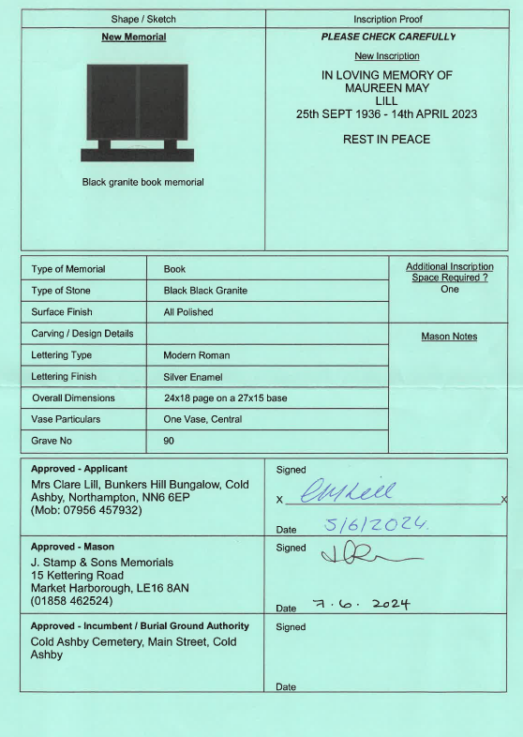
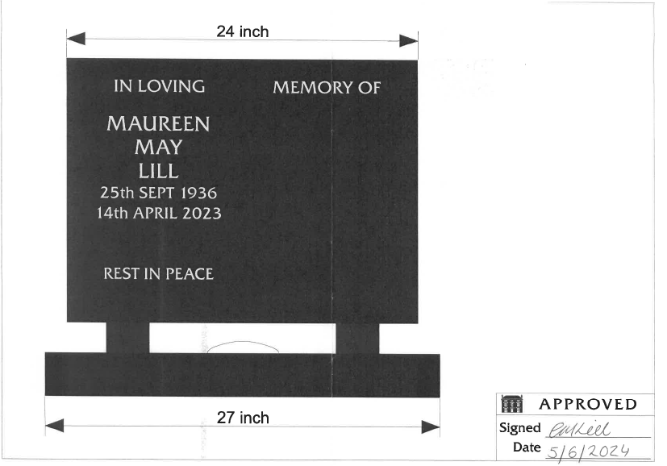

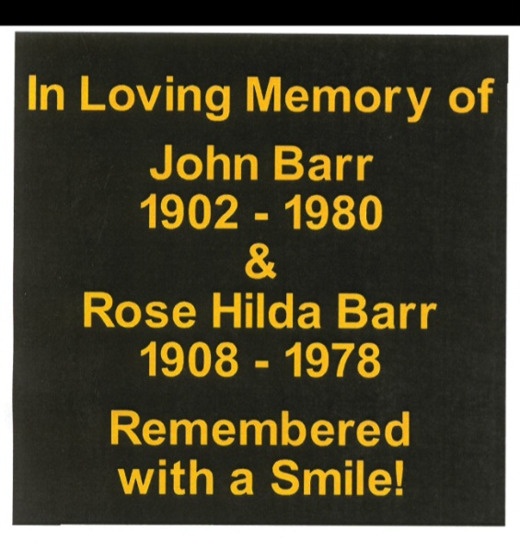
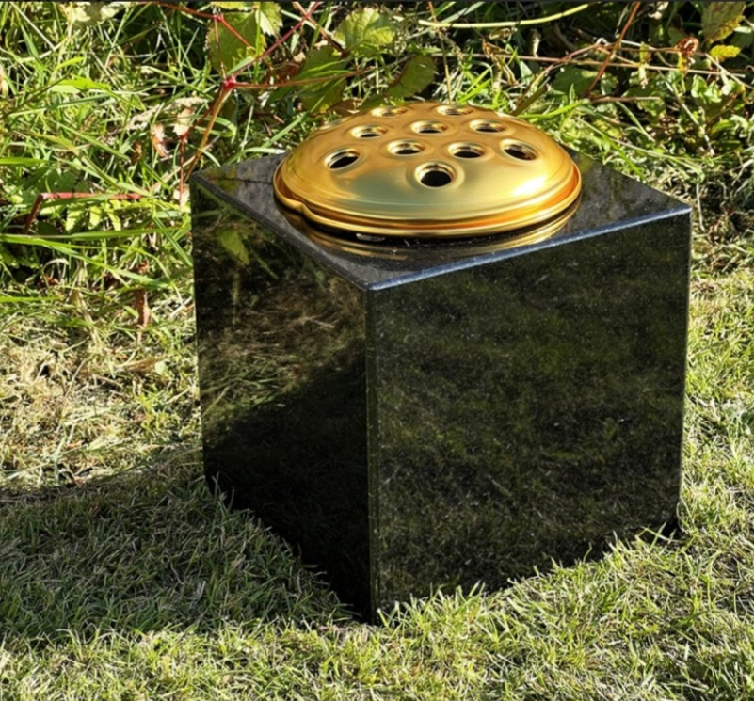

Annex D
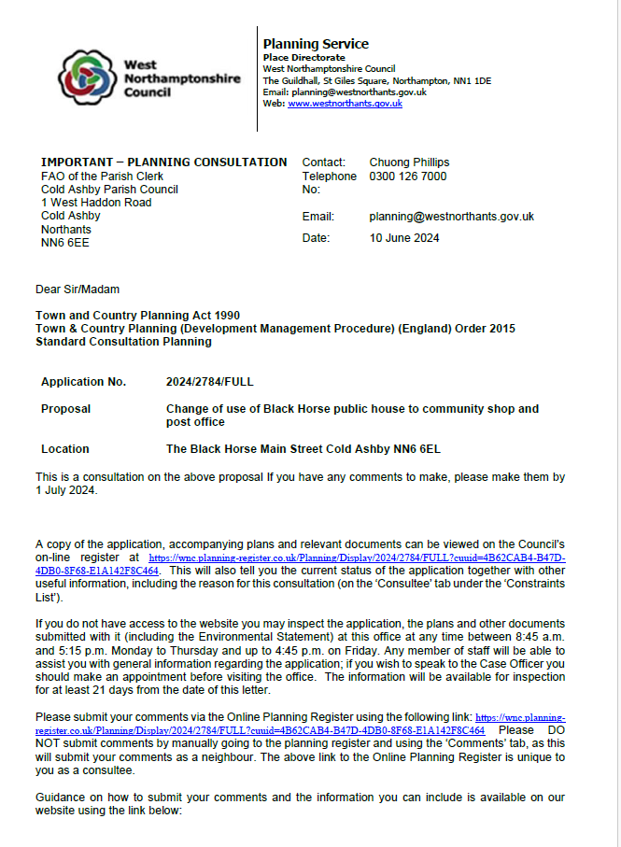

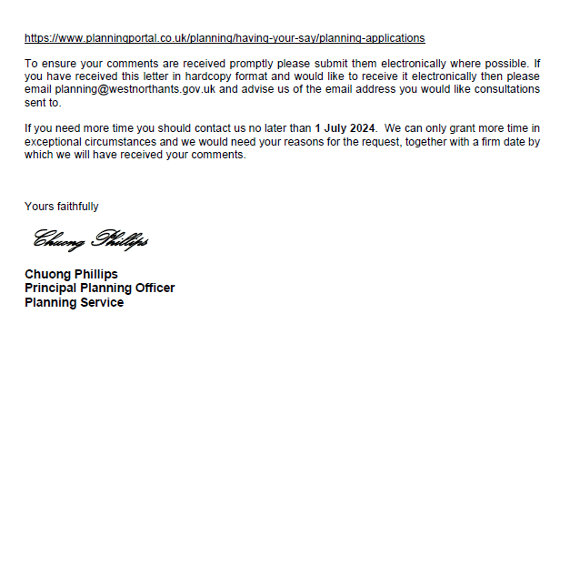

Annex E
